Which calculator to I need for math?
Math 9, Math 10-3 & Math 10C | Math 20-1, Math 20-1  Math 30-2, Math 30-1 | Math 20-3 & Math 30-3
Scientific Calculator  Texas Instruments  TI-30XIIS  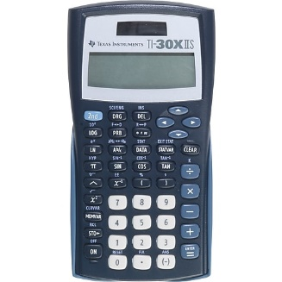  Casio FX-300ESPLUS Scientific Calculator  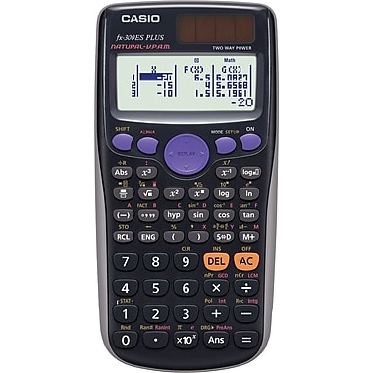 | Graphing Calculator  Texas Instruments  TI 84 Plus  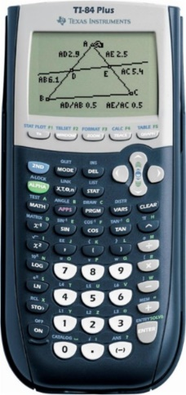  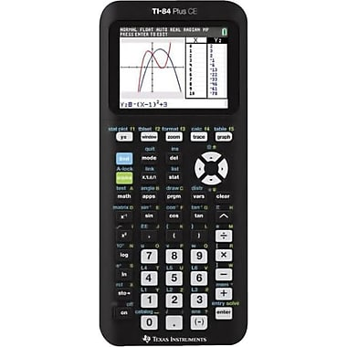 | Scientific Calculator  Texas Instruments  TI-30XIIS  Casio FX-300ESPLUS Scientific Calculator

*Students in Math 10C are welcome to purchase the Texas Instruments
TI 84 Plus so they learn how to use it in grade 10 but it is not required until grade 11.

